Common modules
Common modules are designed to contain texts of functions and procedures that can be called from any other configuration module. Such procedures and functions must contain the Export keyword in the title.
Procedure RecalculateTotalOfDocument(Document) Export

Function DiscountPercentage(Product, Date) Export
In addition to export procedures and functions, ordinary procedures and functions can be created in common modules; they can be called only within the module in which they are located. Typically these are procedures and functions that perform a service purpose, i.e. used in other procedures and functions that can be called by the user (export).
Common modules have a number of properties, which we will discuss next. The properties of a shared module can only be seen in the Properties palette because the shared module does not have an object editor.
We have already seen a description of the flags that define the code execution context for common modules in the client-server lesson. Let me remind you of this information, from the point of view of the code execution context (on client, on server), common modules are divided into 4 types:
- client. Can only be called from the client and is executed only on the client
- server. Can only be called from the server and is executed only on the server.
- client-server. Can be called from both the client and the server. Executed in the same context from which it was called.
- server with the ability to call the server (server call). Can be called from the client and from the server, but is executed only on the server.
Next you can see the flag settings for the listed types of modules.
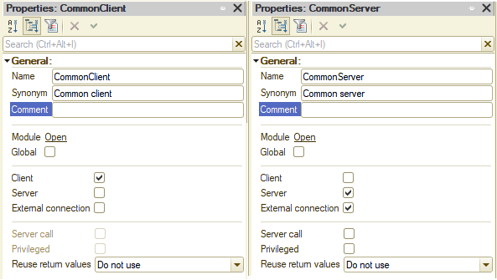
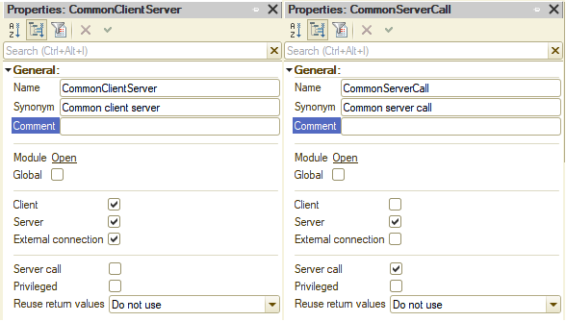
Let's take a closer look at some of the properties and features when working with common modules. The “External connection” flag indicates whether a common module should be available for calling in a session that was not started interactively (i.e., the connection to the database was made externally and a user did not start the database in enterprise mode), for example, accessing an HTTP service or Web -service starts a session in an external connection. This flag should be enabled for server and client-server modules.
The Global property determines whether the exported methods of a common module are part of the global context, i.e. these methods can be accessed directly as built-in platform methods, without specifying the module name.
If the Global property is set to False, then a property is created in the global context with a name that matches the name of the common module in the metadata. This property is read-only. The value of this property is the CommonlModule object. Exported methods of this common module are available through this object. Thus, accessing methods of non-global shared modules looks like XXXXX.YYYYY, where XXXXX is the name of the property corresponding to the context of the shared module, and YYYYY is the name of the exported method of the shared module.
Thus, an object of the common module type can be placed in a variable, through which you can subsequently access the export methods of this common module.
Examples:
// Calling a Global module method
FillPricesInTabularSection(TabularSection, Date);
// Calling a non-global module method
Pricing.FillPricesInTabularSection(TabularSection, Date);

// Writing a common module object to a variable
// and calling a method of this common module via that variable
MyVariable = CommonModuleWithAVeryLongName;
MyVariable.ProcedureOfTheCommonModule();
Everything is quite simple with the client and server modules, but for the client-server and the server call modules there are certain rules:
- Client-server modules should be designed in such a way that all work is performed in a single context. This means that it is unacceptable that when a client-server module is called from a client, execution passes to the server from this or even other modules.
Incorrect 1:
Form module -> Client-server module -> Module with the "Call server" flag
Incorrect 2:
Form module -> Client-server module -> Client module -> Module with the "Call server" flag
Correct:
Form module -> Client module -> Module with the "Call server" flag
- When calling modules with the "Server call" flag from the client, you should remember that not all objects can be transferred between the client and the server. For more information about whether an object can be transferred from the client to the server or vice versa (as well as about the context in which a particular object is available), you should read the syntax assistant. Usually we can’t transfer from the client to the server (or vice versa) objects, , which do not exist on the client or server, such as CatalogObject, DocumentObject, as well as collections ValueTable or ValueTree. Also we can’t transfer form data collections (attribute with FormDataStructure, FormDataCollection, FormDataTree, FormDataStructureAndCollection. When changing these objects on the server side after passing the object from the client, an error occurs when returning to the client execution context) and some which does not exist in the thin client context.
FileDialog doesn’t exist on the server side:
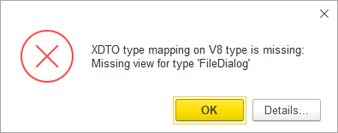
ValueTable object doesn’t exist on the client side:
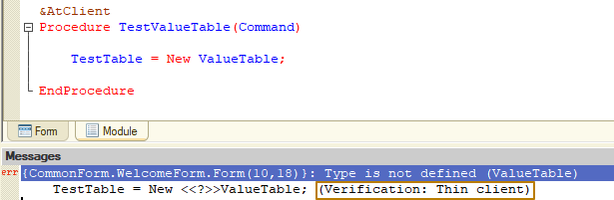
Error on returning modified data form structure from the server to the client side:
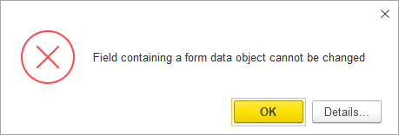
Each client-server module, when compiling a program, turns into 2 copies of the module: client and server. Moreover, such copies of modules may contain differences that the developer can include when writing module code using preprocessor directives.
Some mechanisms are not available on the client or server, then the developer can place certain code inside the condition according to the preprocessor directive, so that such code, when compiled, will only end up in a copy with a context within which all objects and calls are available and execution of the code will not lead to an error .
For example, writing to the event log is not possible in a thin client, so you can add a check into a procedure:
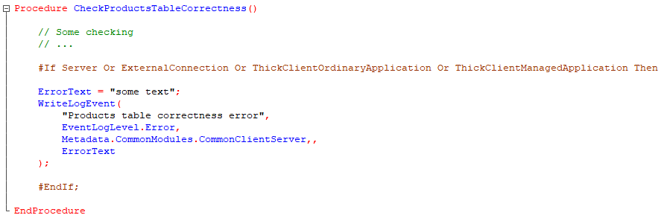
Then in the client copy of the module the procedure will look like this:
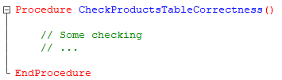
And in the server copy it will look like this:
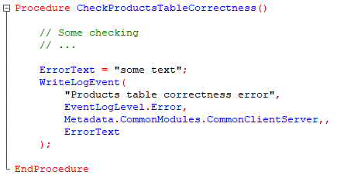
Note: preprocessor directives can be more general and detailed, for example, the condition
#If Server contains checks #If MobileAppServer Or MobileStandaloneServer
And the condition
#If Client contains checks for all clients, including thick client, web client, mobile client, etc.

Full list of preprocessor directives for conditions:
- Client
- Server
- ThinClient
- WebClient
- MobileStandaloneServer
- MobileAppClient
- MobileAppServer
- MobileClient
- ThickClientOrdinaryApplication
- ThickClientManagedApplication
- ExternalConnection
The Privileged property is intended to disable access rights control when executing methods of a common module. That is, in such a module, all code will be executed with full rights and no access restrictions will apply. You will learn more about restricting access in the lesson on roles and access rights.
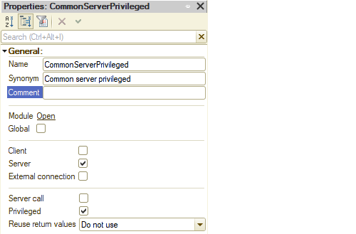
Note: If the Privileged property is set, then the Server property of the shared module is automatically set and the remaining properties (Client (ordinary application), Client (managed application) and External connection) are reset. A privileged common module can only be executed on the server side.

Reusing returned values
If the common module is not global, the “Reuse return values” property becomes available. This property can take the following values:
● Do not use - there is no reuse of return values for functions in this common module.
● During call and during session - the common module uses a method to determine data reuse. The essence of this method is that during code execution, the system remembers the parameters and the result of the functions after the first call to the function. When a function is called again with the same parameters, the stored value (from the first call) is returned without executing the function itself. If a function changes the values of parameters during its execution, then calling the function again will not do this.
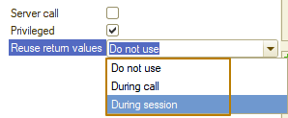
The following features of saving call results can be highlighted:
● if a function is executed on the server and called from the server code, then the parameter values and the result of the call are remembered for the current session on the server side;
● if the function is executed on a thick or thin client, then the values of the parameters and results of the call are remembered on the client side;
● if a function is executed on the server side and called from client code, then the values of the call parameters are remembered both on the client side and on the server side (for the current session).
Saved values are deleted:
- if the common module property is set to During call:
● on the server side - when returning control from the server;
● on the client side - when a top-level built-in language procedure or function is completed (called by the system from the interface, and not from another built-in language procedure or function);
- if the property is set to During session:
● on the server side - at the end of the session (or after a certain time, details in the next paragraph);
● on the client side - when closing the client application (or after a certain time, details in the next paragraph).
The saved values will be deleted:
● on the server, in the thick client, in the external connection, in the thin client and in the web client with a normal connection speed - 20 minutes after calculating the stored value or 6 minutes after the last use;
For example, if after the first call, the function of a value-reusing common module is called every 5.5 minutes, then three calls will return the previously calculated value, and the fourth call will result in the function being re-executed and the return value being saved again, because this call will occur 22 minutes after the value is saved.
● in a thin client and a web client with a slow connection speed - 20 minutes after calculating the saved value;
Infobase settings:
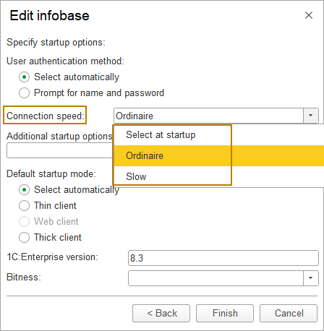
● if there is a lack of RAM in the server’s working process (meaning the working process of a 1C Enterprise server cluster);
● when restarting the working process;
● when switching a client to another working process.
After the values are removed, the call to the exported function is performed as in the first call.
Note: This property of common modules does not affect the execution of procedures - procedures are always executed.
If a common module is set to reuse return values, then a number of restrictions are imposed on the types of parameters exported by the function. Parameter types can only be:
● Primitive types (Undefined, NULL, Boolean, Number, String, Date).
● Any references to database objects.
● Structures with property values of the above types. In this case, the identity of the parameters is controlled “by the contents” of the structures.
If the exported function returns an object, it actually returns a reference to the object stored in the cache. If, after receiving this reference, the object's state changes, then a subsequent call to the same function will return a reference to the already modified object without actually executing the function. This behavior will continue until the stored value is deleted (for any reason). In other words, changing the state of an object resulting from a function call from a common module with reuse of return values is not the basis for the actual function call.
You should also remember that the return object cache is indifferent to the state of the privileged mode at the time the function is called with reuse of return values. This feature can lead to the following behavior:
● The actual execution of the function call that reused the return values (the first call) was done with privileged mode enabled.
● When executing a function, an object was received that could not be received with privileged mode disabled.
● Subsequent calls to the function were executed without setting privileged mode.
● However, until the return object cache is cleared or the actual call is made again, the function will return a formally inaccessible object.
● The reverse behavior is also true, when the first call is made without setting privileged mode, and privileged mode does not return an object that could have been obtained in privileged mode.
If a common module's property Reuse of return values is set to “During session”, then in the values returned by the functions of such a module, values of the type TemporaryTableManager, Query and application objects (for example, DataProcessorObject or DocumentObject) cannot be used, both directly and as part of any collection. The exception is data of reference types (DocumentRef, CatalogRef, etc.).
If a function of a common module with reuse return values set is called from the same common module (for example, with the name of the module Pricing), then you should remember the following feature: if the function is called by the short name (for example MyFunction()), then the function will be executed on each call. In order for the stored values to be used, the function must be called by its full name: Pricing.MyFunction().
To delete all stored values of modules with reused values, there is a global context method RefreshReusableValues(), it deletes all values both on the server side and on the client side, regardless of where the method is called. After executing the RefreshReusableValues() method, the first function call will be executed completely. However, this method can take a long time to execute, so it should not be used unless really necessary.
Purpose and use
It is recommended that code that relates to a subsystem rather than a specific object be placed in common modules. For example, in my document Sales invoice I have a check for the fullness of the “Amount” column in the Products tabular section, where promotional products may have a zero price, but other products may not. I need to implement exactly the same check for the document Return of goods from customer. Most of the code is the same, so in order not to duplicate the code for both documents, I can move it into the export procedure of the Sales common module and call it from the documents.
Sales common module (server module):
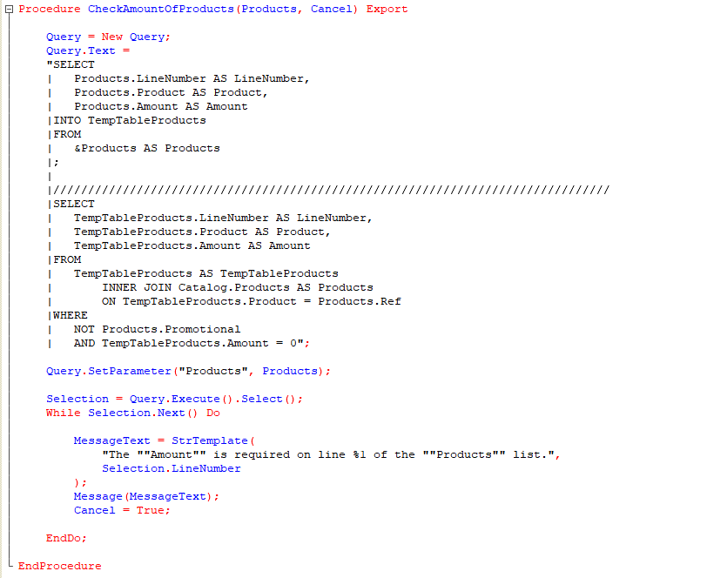

Calling the procedure of the Sales common module from a document object module:
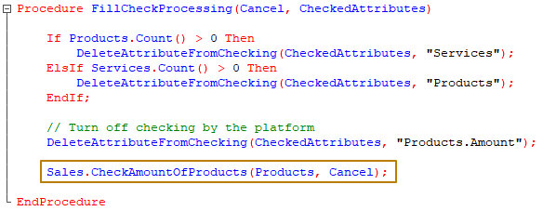

Application module
An application module is a module that is automatically executed when the configuration is loaded when the 1C:Enterprise system starts in the following modes:
● thin client,
● web client,
● a thick client in managed application mode (there is also a thick client in regular application mode, but it is used only in old configurations and is disabled by default in all new infobases).
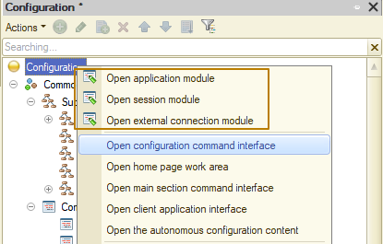
The application module is designed to handle actions related to the user's session (primarily processing the start and end of the session). The application module is not available to procedures running on the server. It is recommended to implement only handlers for the corresponding events. It should be remembered that an unhandled exception in any event handler of a managed application module (BeforeStart(), OnStart(), BeforeExit(), OnExit()) will cause the entire system to crash.
In this example an application will crash:
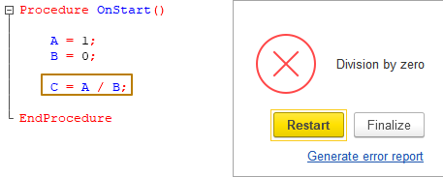
And in this case it will not happen, because an exceptional error is caught in the Except block:
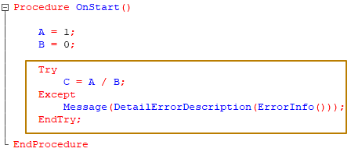
An application module procedures and functions, as well as variables that have the Export keyword in their header, are available:
● in non-global client common modules,
● client procedures and command module functions,
● client procedures and form module functions.
In the context of an application module, the following are available:
● part of the global context that can be executed on the client side;
● exported procedures and functions of any client common modules;
● exported procedures and functions of server non-global common modules that have the “Server call” property set.

External connection module
The external connection module is located, like the application module, in the root section of the configuration. It contains event handler procedures that are initialized when the system starts and ends in external connection mode (for example, HTTP-service).
In the external connection module, it is possible to declare variables, as well as declare and describe procedures and functions that will be available to the external application.
1C:Enterprise objects accessible externally via the external connection mode:
● exported procedures/functions of the external connection module;
● exported procedures/functions of common modules:
● inclusion and exclusion of modules are entirely performed by setting the properties of common modules;
● inclusion and exclusion of fragments of common modules are performed using preprocessor instructions;
● global context of 1C:Enterprise script language.
The module is present only in the external connection session. This mode is characterized by a complete absence of a user interface.
Session module
A session module is a module that is automatically executed when the 1C:Enterprise system starts and the configuration is loaded.
The session module is designed to initialize session parameters and perform actions related to the work session. This common module is always executed in the privileged mode of the 1C:Enterprise server. Setting session parameters is performed in the SessionParametersSetting() event handler.
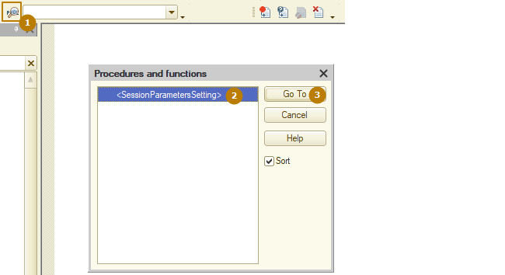
A session module can only contain procedure and function definitions, can use procedures from common configuration modules, and does not contain exported procedures and functions.
The SessionParametersSetting() handler is called before the event handler BeforeStart() (OnStart() in the case of an external connection module) is called.
When executing the SessionParametersSetting event handler, you may need to determine which session is starting: a background job or some other one. This may be necessary if the amount of data being initialized for the background job is significantly different from the amount of data being initialized for other sessions. You can determine the session type using the GetCurrentInfoBaseSession() and GetBackgroundTask() methods. The first method returns a description of the current session - an InformationBase Session object. Calling the GetBackgroundJob() method on the received object will allow you to unambiguously understand whether a background task session is starting or some other session.
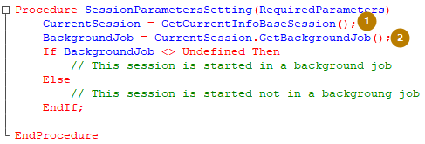
Commands
A command is a configuration object that a developer can use to describe actions to be performed by the user.
There are different commands in 1C Enterprise:
- Standard; those generated by the platform based on the configuration
- Object commands; for example, a catalog or register may have their own commands
- Common commands are commands that do not have object specificity or are used to perform actions with objects that do not use standard commands.
Everything is quite simple with standard commands - these are commands that the platform generates automatically for user interaction with configuration objects. For example, a developer created a Products catalog and added it to the “Master data” subsystem, then the platform automatically adds a command to open the Products catalog list form in this subsystem. On the list form there will be a “Create” button to create a new product - this is also an automatically created command.
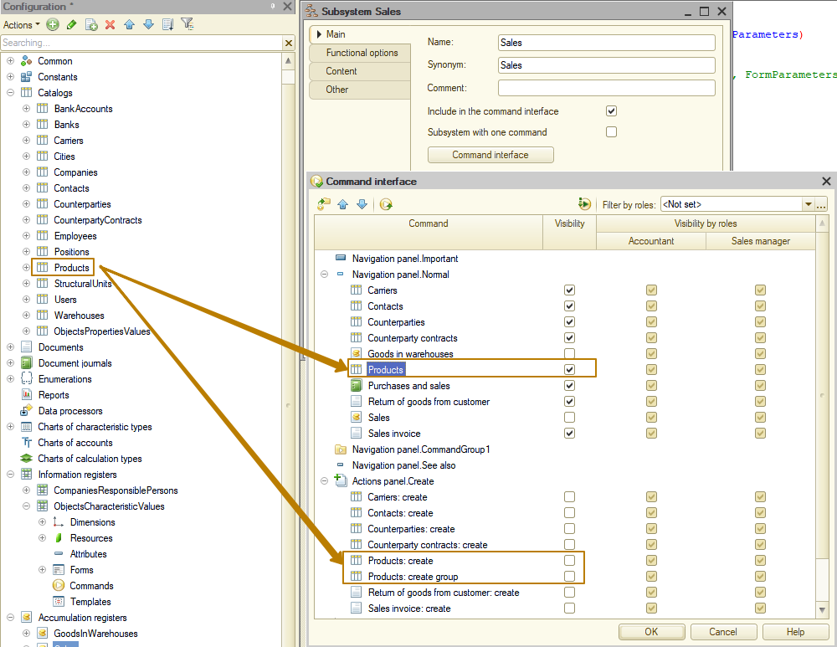
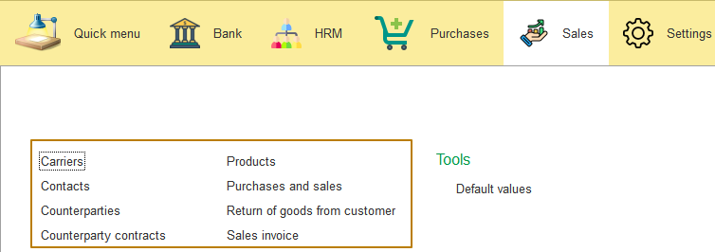
At the same time, the platform also creates a command for creating a new object (catalog, document, etc.) in the subsystems that include the object, but by default this command is disabled and the developer can enable it.
This is what the command looks like on the current section functions panel:
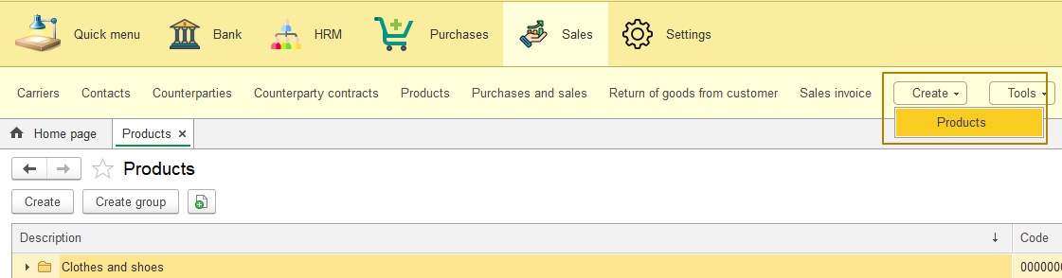
This is what the command looks like on the function menu (when the current section functions panel is turned off):
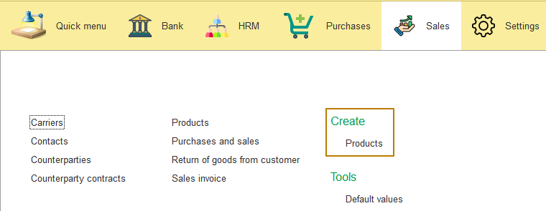
Examples of object commands: create a new object with certain filling rules, open some intermediate object form, etc.
Examples of global (common) commands: change password for current user, send email, open exchange settings with another system/systems.
Now let's talk about the classification of commands. There are two categories that affect the placement of commands in the command interface: command dependency on additional data and command purpose.
Depending on the data, commands are divided into:
• independent,
• parameterizable.
Commands are divided according to their purpose to:
• navigation commands,
• action commands.
Independent and parameterizable commands
Independent commands do not require any additional data for their execution. This means that the result of executing such a command will be the same regardless of which window (or form) the command is called from, what data is being processed by the user at the time the command is called, etc. Independent commands include commands for opening a form (like catalog list form, document form on creating a new document), launching some processes, for example, calculating the cost of goods, etc.
For example, as a result of executing the Products command in the work area of the main application window, the list form of the Products catalog opens. In this case, the command does not require additional information to open the list form.

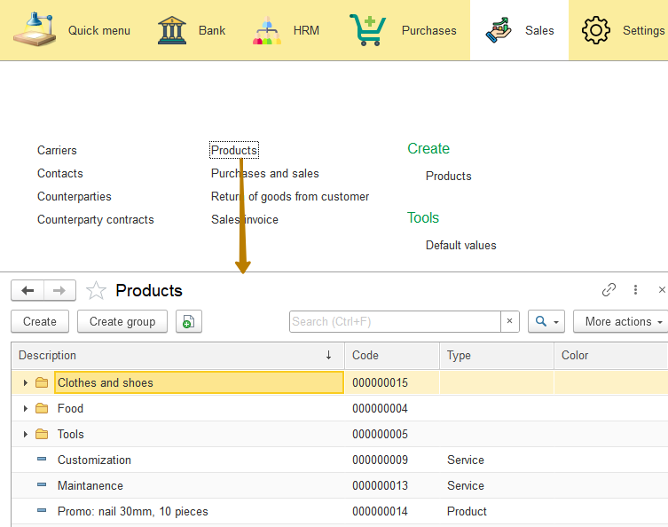
Parameterizable commands require additional data for their execution - command parameter, which determine the result of the command execution. Parameterizable commands include commands for opening a list of a subordinate catalog (parameter is a reference to an element of the owner catalog), creating a new document based on an object (parameter is the object on the basis of which the document is created), as well as any processing that needs to be performed with a reference to any object (for example, download the rate of a certain currency), etc.
For example, here are the commands for jumping to register records subordinate to a specific document:
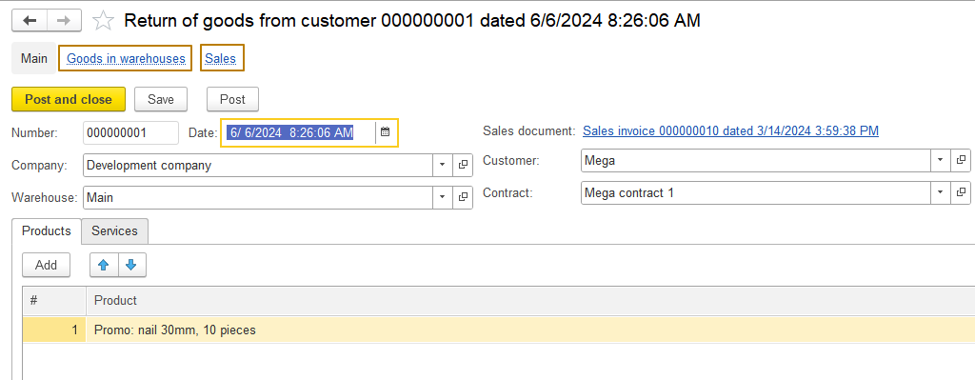

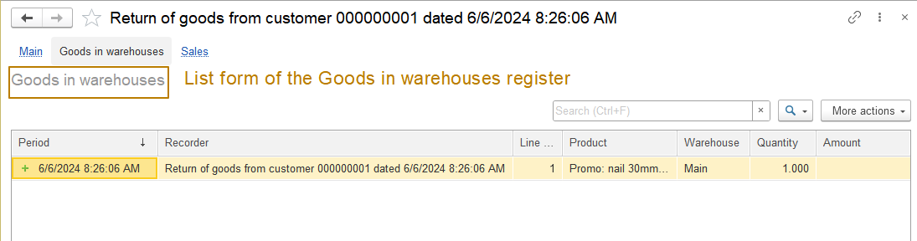 The platform makes our work easier by providing such standard commands, since otherwise we would have to write our own parameterizable commands that open the register list form, passing a reference to the document as a filter for the list.
Let's create our own parameterizable command. For example, the command to create a document Sales inovice, which can be called from the Products catalog. When you click on the button, a new document form should open, which in the Products (or Services) tabular section will have a line with the passed product.
I create an object command for a document, give it the synonym that I want the user to see and select property values:
- Group - command panel of the form. General
- Command parameter type - CatalogRef.Products
- Parameter usage mode - Multiple
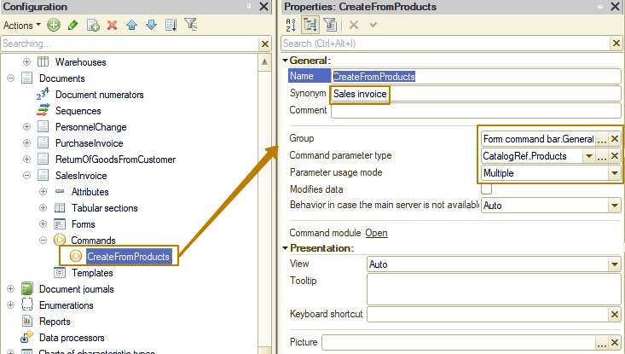
Next, I move on to the command module, in which a handler procedure for the command is created by default
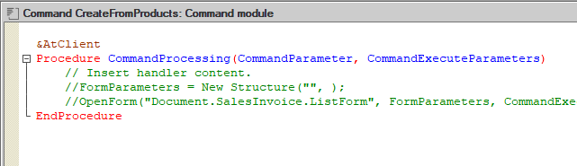
My task is to transfer into the document all the goods and services that were selected before calling the command (the command is available not only in the item form, but also in the list form of Products catalog), and then modify the Filling event handler, since tabular sections cannot be filled automatically by this event .
If the parameter usage mode is Single, then the Command parameter type contains a reference, in my case the mode is Multiple, so the parameter contains an array of references. I pass this array without changes to the Products property of the FillingValues structure and call the opening of the document form and pass there the parameter structure containing the FillingValues:
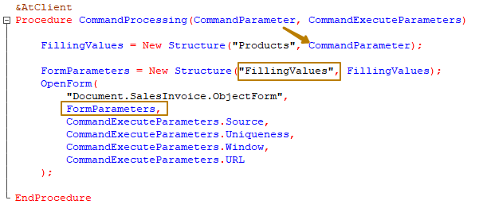
Next, in the Filling event handler, I check the type of the FillingData parameter; if it is a structure, then I check whether it has the Products property; if so, I call the procedure I created that fills the Products and Services tabular sections according to the transferred data.
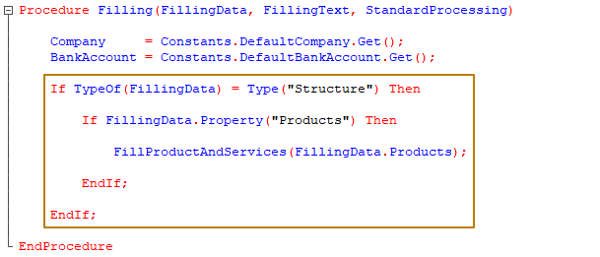
I fill the quantity with 1. This algorithm can be modified by getting current prices and by implementing any other changes:
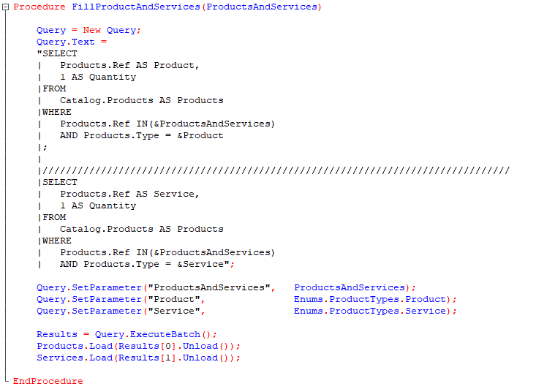
As a result, in the item and list forms of the Products catalog, a button appears in the Generate submenu:
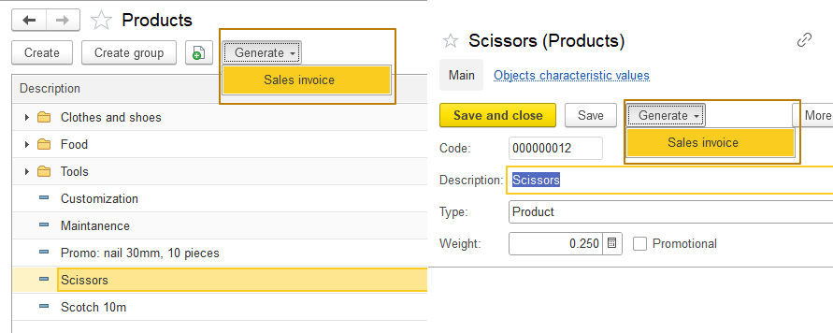
In the list form you can select several items, for example, both a product and a service, then both tabular sections will be filled in the document:
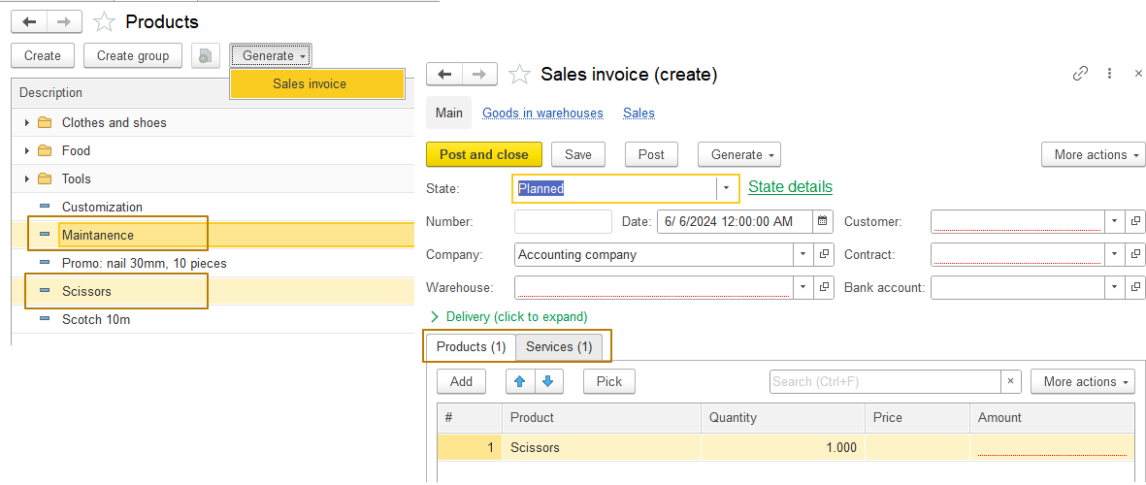
Navigation and action commands
Navigation commands are designed to navigate the user through the functionality of the applied solution. Executing a navigation command usually opens a new list form in the window from which the command was invoked. If any form was displayed in the working area of the window, it is replaced with a new one.
Navigation commands can be either independent or parameterizable global commands. The navigation command includes the command to go to the catalog list form - this is an independent command; The command to go to the list form of a subordinate catalog is a parameterizable command.
Each referential object has a parameterizable "Show in list" navigation command, which opens a list form in which the row with a reference to the object from which the button was clicked is highlighted.
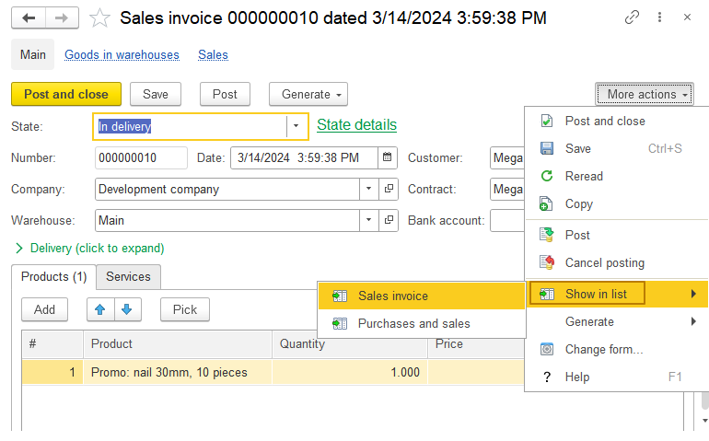
In this case, “Show in list” is a submenu with two buttons, since in addition to the document list form, the document is part of the Purchases and Sales document journal.
If you start entering a string in a field with a reference type to search for an object and then click the "Create" ("create item") button, a parameterizable action command will be executed - the form for creating a new object will be opened, where in the field associated with the attribute for the default presentation (except for documents that do not have the "Default presentation" property) will contain the text entered by the user:
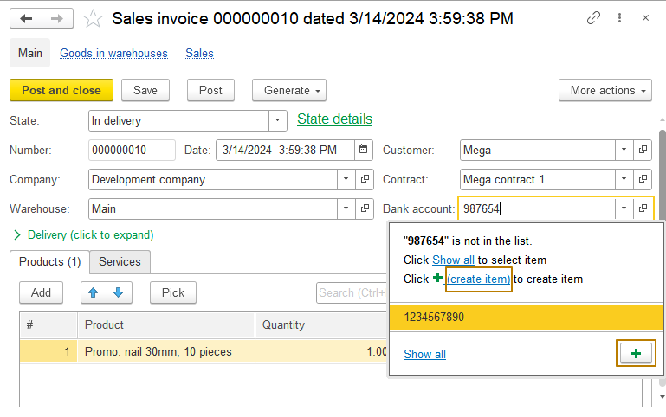
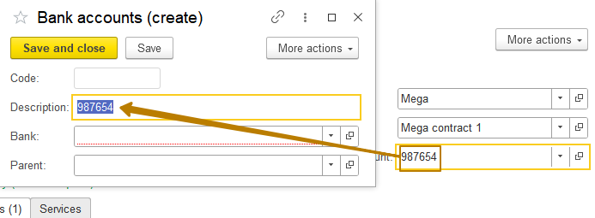
Note: To have an ability to create new objects when entering reference values, it is necessary that the "Create on input” property is set to "Use" for the object (or attributes that refer to that object)
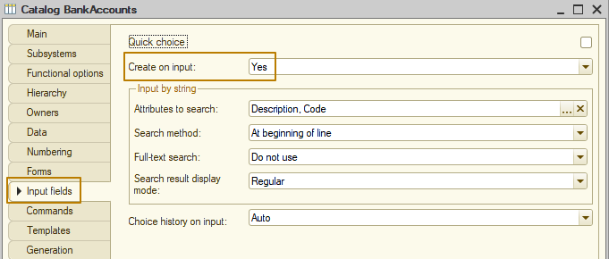
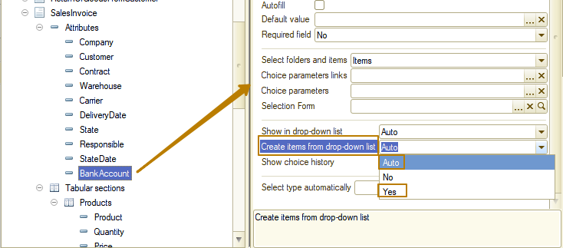
Command groups
Command groups are designed to bring commands together. It is simply a tool that makes it easier to place commands in a command interface. It is enough to specify one of 4 categories (Navigation panel, form navigation panel, action panel, form command bar) for a group of commands, and for created commands, select the created command group in the Group property.
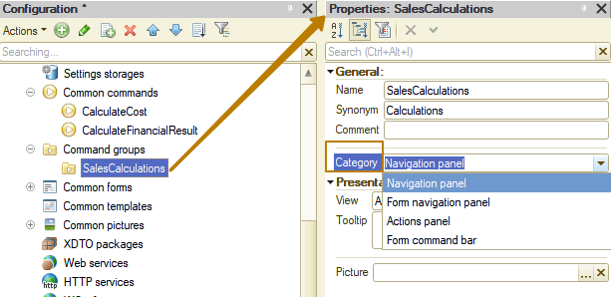
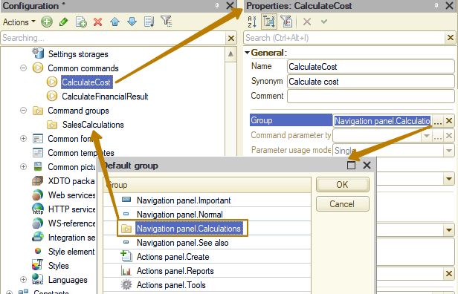

For clarity, I created a group of commands called Sales Calculations, selected the Navigation Panel category for it and included it in the Sales subsystem. Now I create 2 general commands: "Calculate cost" and "Calculate financial result" and include them in the new group. I run the database in enterprise mode and see this result:
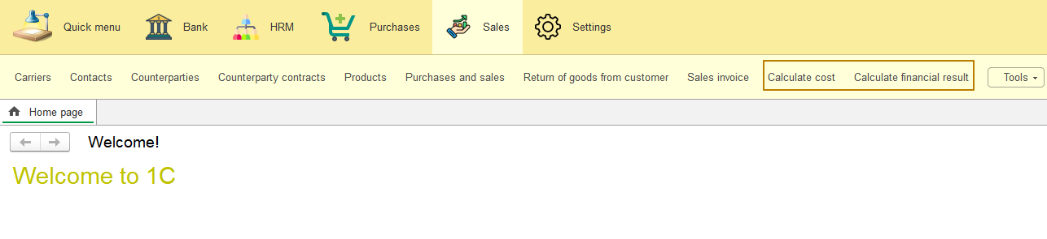
Please note that commands does not group into a submenu at the current section functions panel.
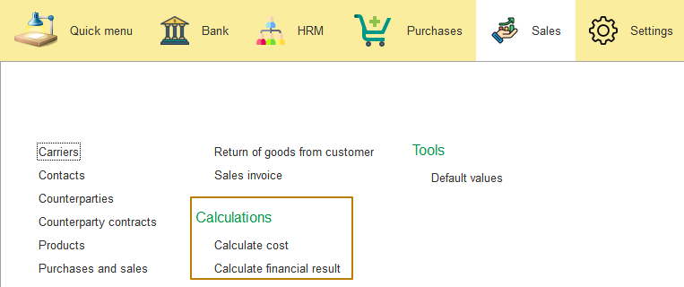
And on the sections panel, commands are combined into a subgroup, as if it were a subordinate subsystem.
Command interface
Configuration command interface
The root configuration object has sections responsible for the command interface available when you right-click or from the properties palette.
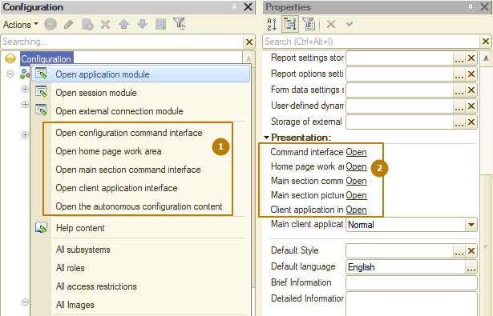
Let's start with the configuration command interface. This property stores:
- setting the order of sections;
- setting the visibility of sections, including the visibility in terms of user roles.
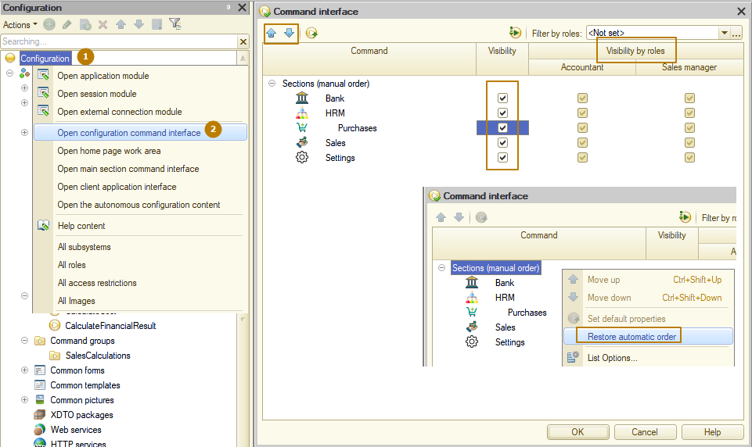
The order of sections can be changed using the up and down arrows, after selecting the needed section. You can change the overall visibility of sections, as well as the visibility of sections by user role. This way, one user can see a certain section while another user does not see it. To reset the order of sections, click on the root Sections in the "Command interface" window and click the "Restore automatic order" button.
Main section command interface
The settings of the main section are saved in the "main section command interface" property of the root configuration object. The main section is the Quick menu service subsystem, located in front of all other subsystems in Enterprise mode.
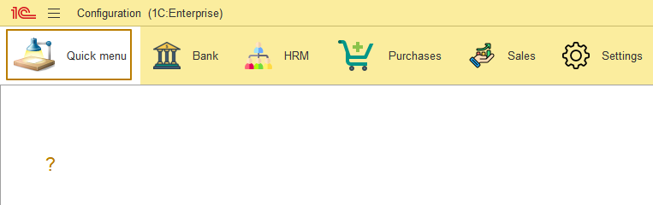 Typically, the most frequently used configuration objects are added to this section.
As you can see, in my configuration the main partition is not filled with anything yet. Let's see how to add any objects there.
I click the "Open main section command interface" button, the following window opens:
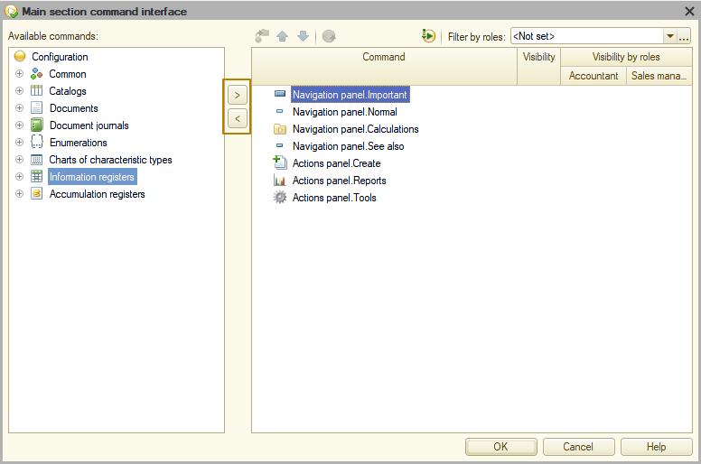
In the window that opens, on the left there is a list of all configuration objects available for placement in the main section. And on the right is the placement of the main section objects on the panels. In order to add or remove an object from the main section, use the "add command" and "remove command" buttons (right and left arrows). I add a document journal and a list of the Products catalog. By default, these objects fall into the Navigation panel.Normal group
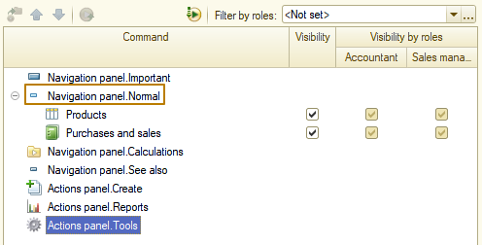
If I want to move an object to another group, I can do this by dragging it. I move the Products catalog to the Navigation panel. Important group
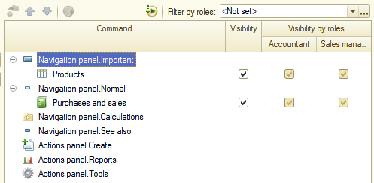
I update the database configuration and check the result:
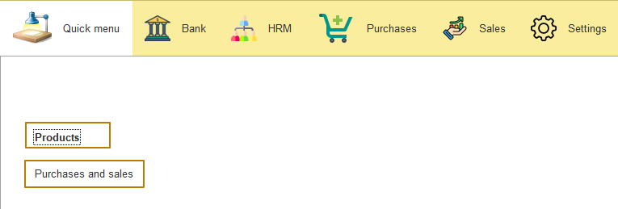 The command for opening the Products catalog is highlighted in bold because it is in the Important group.
"All subsystems" editor
The “All subsystems” editor is designed to manage configuration subsystems, including their command interfaces. You can open the editor from the context menu of the root configuration node and from the context menu of the Subsystems node from the Common configuration branch:
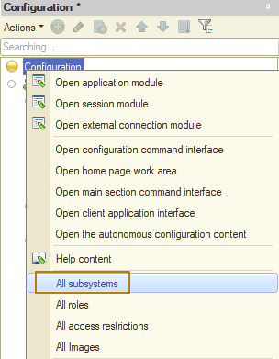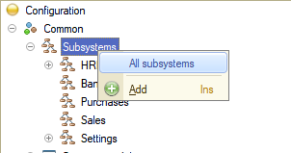
This window is an extended version of the window for working with the command interface of one subsystem. From this window you can add, change and delete subsystems, change their order in the configuration tree (but not in the interface), their content, and also turn on and off the visibility of objects included in the subsystem for all or for individual roles:
